Art Style guide

By: Ryan Frenken

A pinball game called:

PunkBall

General objects and visual directions:

The dynamic objects inside the pinball machine and the visuals in and around the machine will primarily be flashy, be neon green on black with a high contrast difference.

In image one you can see the most classic pinball machine, the dynamic parts that are interactive are the parts we are going to design with the style of image 2.

Image 2 has the Green on black color scheme, and the neon glowing symbols. The bio-hazard symbol is also fitting for the whole cyberpunk theme we are trying to reach for.

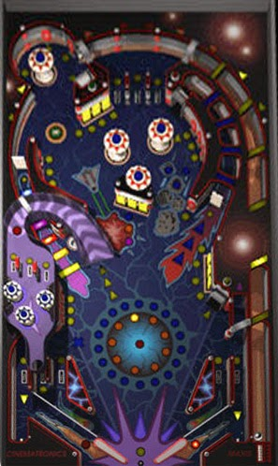Image 1 image 2

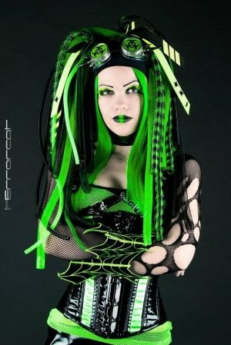Theme choices and overall appearances:

The design of the appearance is what I, the creator relate a lot to and feel comfortable with. Something I enjoy and loving creating cyberpunk themed content. Underneath are 2 examples of the feeling and appearance of the final product should be/feel like. Its usually quite hectic and messy, or even apocalyptic looking. I’m going for a style that has more order in it. The iconic cyberpunk girl will be on the main screen on the pinball machine, as to give the player the feeling she’s a domentrix you’re working for, therefore the order in this theme.

The text will become kind of blocky, and robust. Examples: example 1, example 2, example 3, example 4.

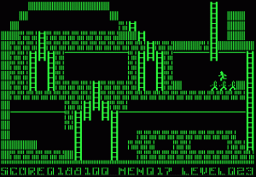

Scoreboard:

There will be a score system, for every dynamic part in the game you hit will award points or bonuses. Those points will be on a counter. I have 2 ideas to execute this, first is to put a simple screen in the eyes of the iconic punk girl that’s in the middle of the 3 screens. It’ll only show 1 bar of text with the current score and game status. On one of the other screens (L or R) will be the high scores list. On the last screen might come a combo and/or other information.

The background of these screens will be a green neon glow. like the rest of the game. It’ll most likely contain a transparent image with the text above.